Fontys University of applied sciences. Eindhoven, Netherlands



Greeting Application Project Plan

Armin Roshan

Internship 01/02/2017



**PROJECT PLAN**

**FONTYS UNIVERSITY OF APPLIED SCIENCES**

**HBO-ICT: English Stream**

|  |  |
| --- | --- |
| **Data student:** | |
| Family name, initials: | **Roshan, Armin** |
| Student number: | **2487128** |
| project period: (from – till) | **Sep2017 - June2017** |
| **Data company:** | |
| Name company/institution: | **GameHouse** |
| Department: | **Service Side (IT)** |
| Address: | **Emmasingel 20, 5611 AZ Eindhoven** |
| **Company tutor:** | |
| Family name, initials: | **Aisyah, Ellya** |
| Position: | **Web developer** |
| **University tutor:** | |
| Family name , initials: | **Li Li L** |
| **Project plan:** | |
| Title: | **Greeting Application** |
| Version: | **0.2** |
| Date: | **09/03/2017** |

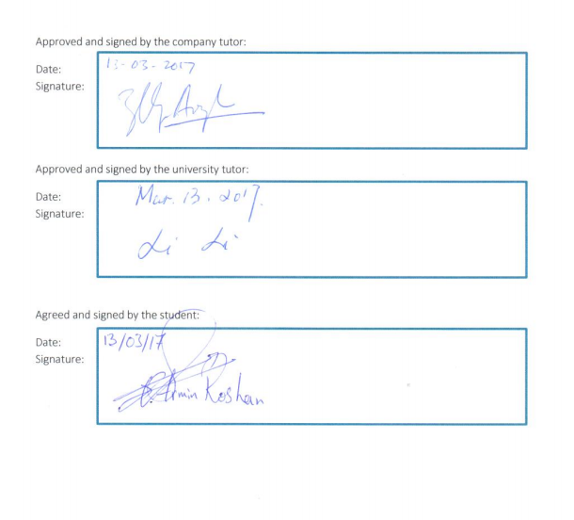

Document History

# Revisions Project plan

|  |  |  |  |
| --- | --- | --- | --- |
| Version | Status | Delivery Date | Final Delivery Date |
| 1.0 | Document Created | 07-02-2017 |  |
| 1.2 | Signed and improved | 09-03-2017 |  |
| 1.3 | Fixed version | 13-03-2017 | March 13th |
|  |  |  |  |

# Revision Project report

|  |  |  |  |
| --- | --- | --- | --- |
| Version | Status | Delivery Date | Final Delivery Date |
| 1.0 | First draft | 20-04-2017 |  |
| 1.2 | Second draft | 01-05-2017 |  |
| 1.3 | Fixed version | 10-05-2017 | June 12th |
|  |  |  |  |

# Contents

Revisions Project plan 3

Revision Project report 3

Contents 4

1 Introduction 6

1.1 About GameHouse 6

1.2 Problem statement 6

1.3 Project Member 6

1.4 Contact information 7

1.5 Method of working 7

1.6 Project definition 7

2 Project Statement 7

2.1 Formal client 7

2.2 Project leader 7

2.3 Current situation 7

2.4 Problem Justification 7

2.5 Project Product 8

2.6 Project Deliverables & Non-deliverables 8

2.6.1 Deliverables 8

2.6.2 Non-Deliverables 8

2.7 Project Constraints 8

2.8 Project Risks 8

3 Project Phasing 9

3.1 Planning description 9

3.2 Milestones 10

3.3 Backlog 10

4 Management Plan 10

4.1 Skills 10

4.2 Quality 11

4.3 Information 12

4.4 Time 12

4.6 Organization 13

# Introduction

The introduction section, introduces GameHouse Europe BV, explains the problem statement, provides contact information, explains the hierarchy in the company, as well as way of working and project definition.

## About GameHouse

GameHouse Europe BV is a game development company with headquarters located in Eindhoven, The Netherlands. And three sub-branches in Utrecht, Alicante, Barcelona. Games are played by people in range of 10 to 65 years old all around a globe. Most games are translated and localized in 7 languages and they are available at [www.gamehouse.com](http://www.gamehouse.com)

Culture in the house is very open. This means, employees of GameHouse will not experience a strict hierarchy system. Colleagues are free to chat and discuss their problems as well as share their thoughts to one and another in constructive and professional manner.

## Problem statement

The assignment is to develop a “Greeting system” for GameHouse in order to welcome external people (visitors) in the office.

Visitor, from stakeholders point of view is, someone who is not an employee of GameHouse and their purpose is to visit GameHouse during working hours only. Visitors could be students, postman, user testers or a person who has an appointment with any of the employees in the company. This product will be installed in the front desk of the company to overcome problems such as employee disturbance as well as visitor confusion. With this system, visitors are able to find their desired target and notify their presence without disturbing any other employees during working hours.

No further information is specified. Hence, it is initially required to develop a website, determine its requirements and verify sufficient depth in terms of implementation and required knowledge.

Below is a list of research questions with regard of this project.

1. Is a website the most suitable solution for this problem?
2. What frontend framework suites the best for this project?
3. What is the best backend language for this project?
4. How to secure the confidential information of employees?
5. How to provide a chat functionality between visitors and employees via the application?

## Project Member

|  |  |
| --- | --- |
| Armin Roshan  ICT & Software Student  Fontys University of Applied Sciences,  Eindhoven |  |
|  |  |
|  |  |
|  |  |

## Contact information

|  |  |  |  |
| --- | --- | --- | --- |
| Name | E-mail | Telephone number | Student number (S/N) |
| Armin Roshan | a.roshan@student.fontys.nl | (+31) 62 829 25 78 | 2487128 |

Table 1‑1 Contact information

## Method of working

The project will be carried out by inter Armin Roshan. Daily stand up meetings with company mentor Ellya Aisyah are held to discuss the upcoming tasks and progress update every morning.

Slack will be used for communication and short updates. Code will be shared and stored using the web-based Git hosting service GitHub.

Scrum is the leading development methodology in the GameHouse. Sprints of two weeks are set to ensure the quality as well as refining and planning for the upcoming sprint.

## Project definition

The main goal of this project is to design and develop a system to welcome external people and visitors to the GameHouse. Stakeholders of this project decided to provide a system that aids external people to find their desired employee when they enter GameHouse, as well as an overview of the company’s sections. To gain more insights into the requirements of this system, interviews will be conducted with Stakeholders.

# Project Statement

## Formal client

Finance assistant, Sam Lasaroms and administrative assistant Janet Damen are the formal clients of this project.

## Project leader

Ellya Aisyah is the project leader of this project, she is a web-developer of GameHouse.

## Current situation

Currently, there is no concrete system that allows external people to be able to find their target or navigate in the company when they enter GameHouse. There is no reception at the front door to direct the person to a right target. Moreover, guests need to wait at the front door until one of the employees notices his/her presences or they need to walk to one of the employees and distract them during the working hours.

## Problem Justification

According to the current situation, welcoming external people to GameHouse is not done in a pleasant way. One of the main problems of the current situation is employee disturbance as well as visitor confusion. Stakeholders believe that installing greeting system with such a functionality where visitors could notify their presence via the application will overcome the problem.

At the end of this project, the stakeholders want to have a system where allow the guests and external people to send quick message to their target employee as well as navigate their way in the company. This system needs to be easy to use for all the people who are coming to GameHouse. This system must also represent GameHouse’s open culture.This application can be installed in all the branches of GameHouse. Using such a greeting system will eliminates the cost of hiring secretary for the company as well.

## Project Product

The product of this project will be a web-based greeting application that will allow the guests to find an employee they intend to meet and navigate though company without getting lost. Guest will be able to search employees by name and chat with them and notify their presences in the company.

## Project Deliverables & Non-deliverables

As mentioned earlier, scrum methodology is used in this project. In scrum projects, main goal of the project might get different direction. This decision is made by stakeholders every sprint. In this way of working deliverables and non-deliverables of this project cannot fully be defined. However, the minimum deliverables and non-deliverables are listed in the subsections below.

### Deliverables

* Project Plan.
* Report.
* Web-Base Application

### Non-Deliverables

* Update
* Training
* User manual

## Project Constraints

* This project must be a Web-Base application.
* Project must be hosted on GameHouse Server.
* User-friendly
* Project must be stored in a repository provided by company when it is completed.
* The methodology used in this project is iterative scrum.

## Project Risks

|  |  |  |
| --- | --- | --- |
| Problem | Impact | Prevention |
| Lack of communication | Medium | Quick updates via slack every day. |
| One of the technical choice cannot be implemented | Low | Research before implementation. |
| Not be able to complete the project before the deadline | Low | Meeting with stockholders and extend the deadline. |

Table 2‑1 Project risks

# Project Phasing

This project will be developed using scrum methodology. There will be sprints during the development phase. Which mean, after each scrum sprint, there will be a meeting with formal client and stakeholders. Outcome of this meeting will be the deliverables of the upcoming sprint. Each sprint will produce a deliverable. Table below is the demonstration of the project phasing. Each color represents a phase during development.

Sprints of The Project

|  |  |  |  |  |  |  |  |  |  |  |  |
| --- | --- | --- | --- | --- | --- | --- | --- | --- | --- | --- | --- |
| 0 | 1 | 2 | 3 | 4 | 5 | 6 | 7 | 8 | 9 | 10 | 11 |
| Daily Stand-Up meetings, Retrospective, demo, review, meeting with mentor  Scholar requirments  Project Plan | Setting up Environment |  | Research and undrestanding  Requirements gathering | Writing project report |  | Defining goals |  |  |  | Formative feedback/evaluation |  |

Concept of project Planning and Definition Execution

## Planning description

The project will be split into multiple 2 week sprints. There will be a planned sprint described with 4 columns: To Do, In-progress, Blocked, and Done. “To Do” represents the user stories, which are split into several tasks. “In-progress” represents the current sprints that the team is working on. “Blocked” represents the sprint which is stopped, because it may require additional help, guidance or it is not possible to finish it. “Done” represents the completed sprints. A task has 3 elements: the task name, the description and the estimated time for finishing that task. A sprint represents all the user stories and task for a whole week. A user story represents multiple task.

## Milestones

There will be several milestones for this project:

* Requirement analysis-M1
* Research-M2
* Setting up the environment-M3
* Implementation-M4
* Testing-M5
* Finalizing the project-M6

## Backlog

In the table below you may have an overview of some of the defined tasks for this project. “Amount of Efforts” defines the difficulty of each task (1 for easy, 5 for difficult).

|  |  |  |  |  |
| --- | --- | --- | --- | --- |
| No. | User Stories | Amount Efforts | Estimated Time | |
| Total Hours | Weeks |
| 1 | Project Plan | 3 |  |  |
| 2 | Creating backlog | 1 |  |  |
| 3 | Project definition | 2 |  |  |
| 4 | Research | 4 |  |  |
| 5 | Define requirements | 2 |  |  |
| 6 | Set up environment | 2 |  |  |
| 7 | Design and wireframes | 3 |  |  |
| 8 | Front-end implementation | 5 |  |  |
| 9 | Back-end implementation | 5 |  |  |
| 10 | Testing | 2 |  |  |
| 11 | Report | 4 |  |  |
| 12 | Presentation | 1 |  |  |

Table 3‑1 Backlog table

# Management Plan

This chapter delves into the, skill, quality, information, time and organization domains of this project.

## Skills

Below is a list of skills need to complete this project.

* GUI/UX design skills.
* Imperative programming (JavaScript): implementing, testing, deployment.
* Declarative programming (HTML, CSS, LESS): implementing, debugging.
* Framework knowledge (AngularJs, Spring boot).
* Backend programing (C#, java).
* Tool knowledge (GitHub, SourceTree).
* Communication, Teamwork, Planning and Scrum skills.

## Quality

Quality of this project will be defined by the stakeholders. However, the list below will represent the overview of some objectives that can be done to ensure a measurable quality project at the end.

* Be consistent and give results as expected.
* Be quick and response to user interaction.
* Clear structure code.
* Easily maintainable and scalable by developer of GameHouse BV Europe.
* User friendly.

Developing the project with all these in mind will guarantee a quality product in the end.

## Information

|  |  |  |  |  |
| --- | --- | --- | --- | --- |
|  | Project plan | Project report | Greeting  System | Final presentation |
| Company mentor | **R, A, Di** | **R, A, Di** | **R, A, Di** | **R, A, Di** |
| Fontys tutor | **R, A** | **R, A, Di** | **R, A, Di** | **R, A, Di** |
| Formal Client | **A, Di** | **A, Di** | **A, Di** | **Dr, Di, S** |
| Stakeholders | **Di** | **A, Di** | **A, Di** | **Di, S, A** |
| Intern | **Dr, Ar, Di, S** | **Dr, Ar, Di, S** | **Dr, Ar, Di, S** | **Dr, Ar, Di, S** |

Table 4‑1 Information overview

Legend: **Dr** Draw up, **Di** Discuss, **A** Approve, **R** Receive, **S** Send, **Ar** Archive

## Time

As demonstrated in the phase chapter, each phase consists of number of sprints (vertical numbers). Below is a breakdown of the time frame allocated to the completion of the project.

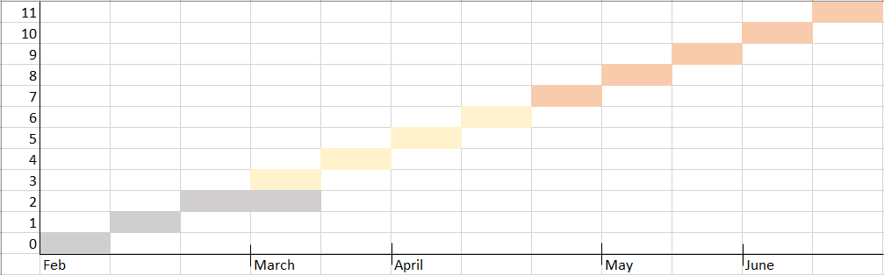

Figure 4.1 Time table for the project. Phase 1 phase 2 phase 3

## Organization

As mentioned in the “method of working” section. Scrum is the leading strategy among the teams in GameHouse. A scrum team in service side is consists of 4 or 5 people that includes the product owner, scrum master and the team member, playing different rolls, such as frontend/backend developer as well as UX designer.

However, in this project I will be working as a full-stack developer. I will be working as a frontend and a backend developer.

At the beginning of each sprint, there will be a meeting with the company mentor and the product owner. In this meeting takes for the up-coming sprint will be defined and finalize in products backlog. During the sprint, there will be a backlog refinement. During refinement, team members will estimate the amount of work for each task and allocate a point for it. At the end of the sprint the team has to have the potential to finish the assigned tasks to them. To summarize, here is an illustration of the specified proceedings mentioned above.

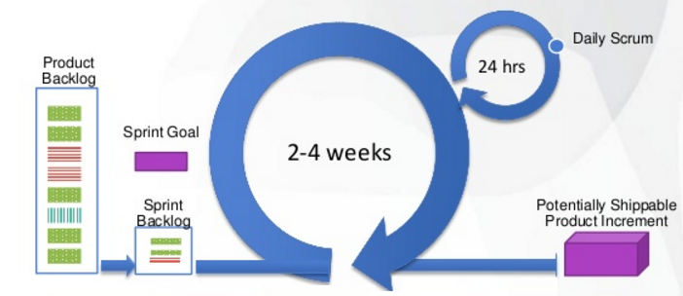

Figure 4.2 Sprint illustration for this project